**ROLE : DATA ANALYST**

**TOPIC : EMPLOYEE ATTRITION**

Dasboards link : <https://public.tableau.com/app/profile/pratham.nayak/viz/EmployeeAttrition_17239834421910/Overalldatadashboard>

Github : <https://github.com/nayakpratham8079/Emplyee-Attrition>

Linkdln : [www.linkedin.com/in/pratham-nayak-3345a3263](http://www.linkedin.com/in/pratham-nayak-3345a3263)

**TABLE OF CONTENT**

|  |  |
| --- | --- |
| 1 | INTRODUCTION |
| 2 | PROBLEM STATEMENT |
| 3 | TECHNIQUES USED TO SOLVE |
| 4 | EMPLOYEE ANALYSIS |
| 5 | ATTRITION ANALYSIS |
| 6 | HIKE PERCENTAGE ANALYSIS |
| 7 | PERFORMANCE RATING |
| 8 | JOB SATISFACTION |
| 9 | ENVIRONMENTAL SATISFACTION |
| 10 | OUTPUTS |
| 11 | RESULTS |
| 12 | CONCLUSION |

**1. INTRODUCTION**

XYZ Company, established a few years ago, has been experiencing a persistent attrition rate of around 15% over the past couple of years. This high turnover rate has significantly impacted various aspects of the company's operations, from employee morale to overall productivity. To address this pressing issue, XYZ Company has sought the expertise of an HR analytics consultancy to analyze their employee data and uncover the underlying factors contributing to this attrition.

In this project, I am assuming the role of an HR analyst tasked with building a comprehensive dashboard that will enable the company to make informed, data-driven decisions aimed at reducing the attrition rate. The dashboard will provide insights into key metrics such as employee demographics, tenure, performance, and other relevant factors that may influence an employee's decision to leave the organization.

Utilizing tools such as Python, Tableau, and Power BI, the project will involve a systematic approach to data analysis, including data preprocessing, exploratory data analysis, and visualization. The goal is to identify patterns and trends within the data that can inform actionable strategies for improving employee retention.

The report will detail the methodologies used, the findings from the data analysis, and the recommendations for reducing attrition. The code will be written in a modular, safe, testable, maintainable, and portable manner, ensuring that the solutions provided are robust and scalable as the company continues to grow.

**2. PROBLEM STATEMENT**

* The company is experiencing a sustained attrition rate of 15%, which is higher than the industry standard. This high turnover is affecting various aspects of the business, including operational efficiency, costs associated with recruiting and training new employees, and overall company culture.
* The key problem to address is understanding the underlying factors contributing to employee attrition and developing strategies to mitigate these issues.
* To create a comprehensive dashboard that provides actionable insights into employee attrition. This dashboard will enable XYZ Company to make informed decisions based on key metrics and trends identified through the analysis.
* The goal is to develop a data-driven strategy to reduce the attrition rate and retain valuable talent.

**3. TECHNIQUES USED TO SOLVE**

### 3.1. Data Preprocessing & ****Data Cleaning****

### Data Preprocessing

Data preprocessing is a critical step in ensuring the accuracy and reliability of the analysis. For this Amazon sales report, several key preprocessing tasks were undertaken to prepare the dataset for analysis:

* **Data Cleaning**:

The first step involved thoroughly cleaning the dataset to address any inconsistencies or errors. Missing values were carefully handled by either imputing them with appropriate substitutes, such as the mean or median for numerical fields, or by removing records where the missing data could significantly impact the analysis. Duplicates were identified and removed to ensure that each transaction was uniquely represented. Additionally, any inconsistencies in data entry, such as variations in spelling or formatting, were corrected to maintain uniformity across the dataset. For example, product categories with inconsistent naming conventions were standardized to ensure accurate categorization.

* **Data Transformation**:

After cleaning, the data was transformed to facilitate analysis. Dates were converted into a consistent format, allowing for accurate time-series analysis. Categorical data, such as product categories and fulfillment methods, were encoded to enable quantitative analysis. New calculated fields were also created where necessary. For instance, fields like "Total Revenue" were calculated by multiplying the quantity sold by the unit price, and "Order Processing Time" was derived by subtracting the order date from the fulfillment date. These transformations ensured that the data was in a format suitable for in-depth analysis, enabling the extraction of meaningful insights.

**3.2. Tools and Techniques**

1. **Data Cleaning and Preprocessing:**
   * Creating new features from the existing data that might have a significant impact on the attrition rate, such as creating a "tenure" variable or calculating satisfaction scores.
2. **Exploratory Data Analysis (EDA):**

**Statistical Analysis:** Descriptive statistics and correlation analysis to identify the key factors associated with employee turnover.

1. **Predictive Modeling:**
   * **Logistic Regression:** Used to model the probability of attrition based on various features. This model helps in identifying the factors that have a statistically significant impact on attrition.
   * **Random Forest:** An ensemble learning method used to rank the importance of different features in predicting attrition. It also helps in building a more robust prediction model.
   * **Support Vector Machine (SVM):** Applied to classify employees into those who are likely to leave and those who are not. It helps in understanding the decision boundary for attrition.
   * **K-Nearest Neighbors (KNN):** Used for clustering employees into different groups based on their similarity in attributes, aiding in targeted interventions.
2. **Dashboard Creation:**
   * **Tableau/Power BI:** Interactive dashboards are created to visualize the key findings, such as the top factors contributing to attrition, department-wise attrition rates, and predicted attrition risk for individual employees.
   * **Dynamic Filtering:** Allows HR managers to filter the data by department, job role, tenure, etc., to get more detailed insights.
3. **Actionable Insights and Recommendations:**
   * **Root Cause Analysis:** Identifying the root causes of high attrition rates, such as dissatisfaction with compensation, work-life balance, or lack of career growth opportunities.
   * **Retention Strategies:** Providing specific recommendations based on the analysis, such as revising compensation policies, improving work culture, offering career development programs, and implementing employee feedback mechanisms.

**4. EMPLOYEE ANALYSIS**

**Table 4.1.No of Employee in Organization**

|  |  |
| --- | --- |
| **Department** | **No of employees** |
| Human Resources | 189 |
| Research & Development | 2883 |
| Sales | 1338 |
| **Grand Total** | **4410** |

From table total number of employees in XYZ company is 4410. In Human Resources department, 189 employees are working. In Research & Development, 2883 employees are working. In Sales department, 1338 employees are working.

**Table 4.2.No Of Employee For Business Travels**

|  |  |  |  |  |
| --- | --- | --- | --- | --- |
|  | No of BusinessTravel | | | Grand Total |
| Department | Non-Travel | Travel_Frequently | Travel_Rarely |
| Human Resources | 9 | 24 | 156 | 189 |
| Research & Development | 330 | 519 | 2034 | 2883 |
| Sales | 111 | 288 | 939 | 1338 |
| Grand Total | 450 | 831 | 3129 | 4410 |

Most non-travel , travel frequently and travel rarely is from Research & Development department.

1. **ATTRITION ANALYSIS**

**Table 5.1.Total Number of Attrition**

|  |  |  |  |
| --- | --- | --- | --- |
|  | No of attrition | |  |
| Department | No | Yes | Grand Total |
| **Human Resources** | **132** | **57** | **189** |
| Female | 51 | 21 | 72 |
| Male | 81 | 36 | 117 |
| **Research & Development** | **2430** | **453** | **2883** |
| Female | 981 | 183 | 1164 |
| Male | 1449 | 270 | 1719 |
| **Sales** | **1137** | **201** | **1338** |
| Female | 462 | 66 | 528 |
| Male | 675 | 135 | 810 |
| Grand Total | 3699 | 711 | 4410 |

The maximum Number of attrition is found from Research & Development department.

**Table 5.2. Age Range Between 19-32**

|  |  |  |  |
| --- | --- | --- | --- |
|  | No of attrition | |  |
| Department | No | Yes | Grand Total |
| **Human Resources** | **36** | **30** | **66** |
| Female | 15 | 12 | 27 |
| Male | 21 | 18 | 39 |
| **Research & Development** | **768** | **255** | **1023** |
| Female | 273 | 111 | 384 |
| Male | 495 | 144 | 639 |
| **Sales** | **357** | **102** | **459** |
| Female | 141 | 30 | 171 |
| Male | 216 | 72 | 288 |
| **Grand Total** | **1161** | **387** | **1548** |

The maximum Number of attrition is found from Research & Development department.

**Table 5.3. Age Range Between 33-46**

|  |  |  |  |
| --- | --- | --- | --- |
|  | No of attrition | |  |
| Department | No | Yes | Grand Total |
| **Human Resources** | **78** | **18** | **96** |
| Female | 30 | 6 | 36 |
| Male | 48 | 12 | 60 |
| **Research & Development** | **1221** | **147** | **1368** |
| Female | 522 | 54 | 576 |
| Male | 699 | 93 | 792 |
| **Sales** | **609** | **69** | **678** |
| Female | 258 | 18 | 276 |
| Male | 351 | 51 | 402 |
| **Grand Total** | **1908** | **234** | **2142** |

The maximum Number of attrition is found from Research & Development department.

**Table 5.4. Age Range Between 47-60**

|  |  |  |  |
| --- | --- | --- | --- |
|  | No of attrition | |  |
| Department | No | Yes | Grand Total |
| **Human Resources** | **18** | **9** | **27** |
| Female | 6 | 3 | 9 |
| Male | 12 | 6 | 18 |
| **Research & Development** | **441** | **51** | **492** |
| Female | 186 | 18 | 204 |
| Male | 255 | 33 | 288 |
| **Sales** | **171** | **30** | **201** |
| Female | 63 | 18 | 81 |
| Male | 108 | 12 | 120 |
| **Grand Total** | **630** | **90** | **720** |

The maximum Number of attrition is found from Research & Development department.

**Table 5.5. Age of 60**

|  |  |  |
| --- | --- | --- |
|  | **Attrition** | **Grand Total** |
| **Department** | **No** |
| **Research & Development** | **9** | **9** |
| Female | 9 | 9 |
| **Sales** | **6** | **6** |
| Male | 6 | 6 |
| **Grand Total** | **15** | **15** |

The maximum Number of attrition is found from Research & Development department.

**Table 5.6. Job Role Attrition (Yes / No )**



1. **HIKE PERCENTAGE ANALYSIS**

**Table.6.1. Range of 11% TO 15% Hike**

|  |  |  |  |
| --- | --- | --- | --- |
|  | **Gender** | | **Grand Total** |
| **Job role** | **Female** | **Male** |
| Healthcare Representative | 99 | 135 | 234 |
| Human Resources | 48 | 63 | 111 |
| Laboratory Technician | 177 | 267 | 444 |
| Manager | 102 | 99 | 201 |
| Manufacturing Director | 102 | 180 | 282 |
| Research Director | 54 | 102 | 156 |
| Research Scientist | 204 | 333 | 537 |
| Sales Executive | 237 | 417 | 654 |
| Sales Representative | 75 | 63 | 138 |
| **Grand Total** | **1098** | **1659** | **2757** |

**Table.6.2. Range of 16%-20%** **Hike**

|  |  |  |  |
| --- | --- | --- | --- |
|  | **Gender** | | **Grand Total** |
| **Job role** | **Female** | **Male** |
| Healthcare Representative | 39 | 63 | 102 |
| Human Resources | 24 | 45 | 36 |
| Laboratory Technician | 105 | 138 | 243 |
| Manager | 30 | 39 | 69 |
| Manufacturing Director | 54 | 57 | 111 |
| Research Scientist | 93 | 159 | 252 |
| Sales Executive | 111 | 105 | 216 |
| Sales Representative | 18 | 42 | 60 |
| **Grand Total** | **492** | **648** | **1089** |

**Table.6.3. Range of 21% -25% Hike**

|  |  |  |  |
| --- | --- | --- | --- |
|  | **Gender** | | **Grand Total** |
| **Job role** | **Female** | **Male** |
| Healthcare Representative | 21 | 36 | 57 |
| Human Resources |  | 9 | 9 |
| Laboratory Technician | 18 | 72 | 90 |
| Manager | 15 | 21 | 36 |
| Manufacturing Director | 21 | 21 | 42 |
| Research Director | 12 | 21 | 33 |
| Research Scientist | 27 | 60 | 87 |
| Sales Executive | 48 | 60 | 108 |
| Sales Representative | 12 | 39 | 51 |
| **Grand Total** | **174** | **339** | **513** |

**SUMMARY**

**Table.6.4. Maximum Hike Percentage**

|  |  |  |  |
| --- | --- | --- | --- |
|  | **Gender** | | **Grand Total** |
| **Job role** | **Female** | **Male** |
| Sales Executive | 237 | 417 | 654 |
| Sales Executive | 111 |  | 111 |
| Research Scientist |  | 159 | 159 |
| Laboratory Technician |  | 72 | 72 |
| Sales Executive | 48 |  | 48 |
| **Grand Total** | 396 | 648 | 1044 |

**Table.6.5. Minimum Hike Percentage**

|  |  |  |  |
| --- | --- | --- | --- |
|  | **Gender** | | **Grand Total** |
| **Job role** | **Female** | **Male** |
| Human Resources | 48 | 63 | 111 |
| Manager |  | 39 | 39 |
| Sales Representative | 18 |  | 18 |
| Research Director | 12 |  | 12 |
| Human Resources |  | 9 | 9 |
| **Grand Total** | 78 | 111 | 189 |

**7.PERFORMANCE RATING**

**Table.7.1. Allover Performance Rating Employee**

|  |  |  |  |
| --- | --- | --- | --- |
|  | **Gender** | | **Grand Total** |
| **Job role** | **Female** | **Male** |
| Healthcare Representative | 159 | 234 | 393 |
| Human Resources | 60 | 96 | 156 |
| Laboratory Technician | 300 | 477 | 777 |
| Manager | 147 | 159 | 306 |
| Manufacturing Director | 177 | 258 | 435 |
| Research Director | 96 | 144 | 240 |
| Research Scientist | 324 | 552 | 876 |
| Sales Executive | 396 | 582 | 978 |
| Sales Representative | 105 | 144 | 249 |
| **Grand Total** | **1764** | **2646** | **4410** |

**Table.7.2. Highest Performance Rating**

|  |  |  |  |
| --- | --- | --- | --- |
|  | **Gender** | | **Grand Total** |
| **Job role** | **Female** | **Male** |
| Healthcare Representative | 24 | 48 | 72 |
| Human Resources | 3 | 9 | 12 |
| Laboratory Technician | 33 | 96 | 129 |
| Manager | 18 | 30 | 48 |
| Manufacturing Director | 21 | 33 | 54 |
| Research Director | 12 | 21 | 33 |
| Research Scientist | 33 | 90 | 123 |
| Sales Executive | 72 | 81 | 153 |
| Sales Representative | 15 | 39 | 54 |
| **Grand Total** | **231** | **447** | **678** |

**Table.7.3. Lowest Performance Rating**

|  |  |  |  |
| --- | --- | --- | --- |
|  | **Gender** | | **Grand Total** |
| **Job role** | **Female** | **Male** |
| Healthcare Representative | 135 | 186 | 321 |
| Human Resources | 57 | 87 | 144 |
| Laboratory Technician | 267 | 381 | 648 |
| Manager | 129 | 129 | 258 |
| Manufacturing Director | 156 | 225 | 381 |
| Research Director | 84 | 123 | 207 |
| Research Scientist | 291 | 462 | 753 |
| Sales Executive | 324 | 501 | 825 |
| Sales Representative | 90 | 105 | 195 |
| **Grand Total** | **1533** | **2199** | **3732** |

1. **JOB SATISFACTION**

**Table.8.1. Overall Job Satisfaction**

|  |  |  |  |
| --- | --- | --- | --- |
|  | **Gender** | | **Grand Total** |
| **Job role** | **Female** | **Male** |
| Healthcare Representative | 159 | 234 | 393 |
| Human Resources | 60 | 96 | 156 |
| Laboratory Technician | 300 | 477 | 777 |
| Manager | 147 | 159 | 306 |
| Manufacturing Director | 177 | 258 | 435 |
| Research Director | 96 | 144 | 240 |
| Research Scientist | 324 | 552 | 876 |
| Sales Executive | 396 | 582 | 978 |
| Sales Representative | 105 | 144 | 249 |
| **Grand Total** | **1764** | **2646** | **4410** |

**Table.8.2. Fully Job Satisfaction**

|  |  |  |  |
| --- | --- | --- | --- |
|  | **Gender** | | **Grand Total** |
| **Job role** | **Female** | **Male** |
| Healthcare Representative | 114 | 126 | 240 |
| Human Resources | 48 | 65 | 113 |
| Laboratory Technician | 173 | 297 | 470 |
| Manager | 93 | 99 | 192 |
| Manufacturing Director | 106 | 166 | 272 |
| Research Director | 69 | 87 | 156 |
| Research Scientist | 177 | 331 | 508 |
| Sales Executive | 233 | 357 | 590 |
| Sales Representative | 63 | 86 | 149 |
| **Grand Total** | **1076** | **1614** | **2690** |

**Table.8.3. Partially Job Satisfaction**

|  |  |  |  |
| --- | --- | --- | --- |
|  | **Gender** | | **Grand Total** |
| **Job role** | **Female** | **Male** |
| Healthcare Representative | 24 | 60 | 84 |
| Human Resources | 12 | 12 | 24 |
| Laboratory Technician | 69 | 89 | 158 |
| Manager | 27 | 32 | 59 |
| Manufacturing Director | 33 | 39 | 72 |
| Research Director | 6 | 26 | 32 |
| Research Scientist | 89 | 87 | 176 |
| Sales Executive | 82 | 104 | 186 |
| Sales Representative | 30 | 39 | 69 |
| **Grand Total** | **372** | **488** | **860** |

|  |  |  |  |
| --- | --- | --- | --- |
|  | **Gender** | | **Grand Total** |
| **Job role** | **Female** | **Male** |
| Healthcare Representative | 21 | 45 | 66 |
| Human Resources |  | 18 | 18 |
| Laboratory Technician | 57 | 90 | 147 |
| Manager | 27 | 27 | 54 |
| Manufacturing Director | 36 | 51 | 87 |
| Research Director | 21 | 30 | 51 |
| Research Scientist | 57 | 132 | 189 |
| Sales Executive | 78 | 120 | 198 |
| Sales Representative | 12 | 18 | 30 |
| **Grand Total** | **309** | **531** | **840** |

|  |  |  |  |
| --- | --- | --- | --- |
|  | **Gender** | | **Grand Total** |
| **Job role** | **Female** | **Male** |
| Healthcare Representative | 48 | 66 | 114 |
| Human Resources | 18 | 29 | 47 |
| Laboratory Technician | 87 | 159 | 246 |
| Manager | 60 | 39 | 99 |
| Manufacturing Director | 49 | 84 | 133 |
| Research Director | 39 | 36 | 75 |
| Research Scientist | 81 | 171 | 252 |
| Sales Executive | 117 | 168 | 285 |
| Sales Representative | 39 | 33 | 72 |
| **Grand Total** | **538** | **785** | **1323** |

**Table.8.4. No Job Satisfaction**

|  |  |  |  |
| --- | --- | --- | --- |
|  | **Gender** | | **Grand Total** |
| **Job role** | **Female** | **Male** |
| Healthcare Representative |  | 3 | 3 |
| Human Resources |  | 1 | 1 |
| Laboratory Technician | 1 | 1 | 2 |
| Manufacturing Director | 2 | 3 | 5 |
| Research Director |  | 1 | 1 |
| Research Scientist | 1 | 2 | 3 |
| Sales Executive | 3 | 1 | 4 |
| Sales Representative |  | 1 | 1 |
| **Grand Total** | **7** | **13** | **20** |

1. **ENVIRONMENTAL SATISFACTION**

**Table.9.1. Overall Environmental Satisfaction**

|  |  |  |  |
| --- | --- | --- | --- |
|  | **Gender** | | **Grand Total** |
| **Job role** | **Female** | **Male** |
| Healthcare Representative | 159 | 234 | 393 |
| Human Resources | 60 | 96 | 156 |
| Laboratory Technician | 300 | 477 | 777 |
| Manager | 147 | 159 | 306 |
| Manufacturing Director | 177 | 258 | 435 |
| Research Director | 96 | 144 | 240 |
| Research Scientist | 324 | 552 | 876 |
| Sales Executive | 396 | 582 | 978 |
| Sales Representative | 105 | 144 | 249 |
| **Grand Total** | **1764** | **2646** | **4410** |

**Table.9.2. Fully Environmental Satisfaction**

|  |  |  |  |
| --- | --- | --- | --- |
|  | **Gender** | | **Grand Total** |
| **Job role** | **Female** | **Male** |
| Healthcare Representative | 54 | 77 | 131 |
| Human Resources | 21 | 36 | 57 |
| Laboratory Technician | 84 | 151 | 235 |
| Manager | 57 | 27 | 84 |
| Manufacturing Director | 39 | 72 | 111 |
| Research Director | 39 | 39 | 78 |
| Research Scientist | 105 | 180 | 285 |
| Sales Executive | 111 | 170 | 281 |
| Sales Representative | 33 | 39 | 72 |
| **Grand Total** | **543** | **791** | **1334** |

**Table.9.3. Average Environmental Satisfaction**

|  |  |  |  |
| --- | --- | --- | --- |
|  | **Gender** | | **Grand Total** |
| **Job role** | **Female** | **Male** |
| Healthcare Representative | 104 | 156 | 260 |
| Human Resources | 39 | 59 | 98 |
| Laboratory Technician | 214 | 320 | 534 |
| Manager | 90 | 130 | 220 |
| Manufacturing Director | 138 | 184 | 322 |
| Research Director | 57 | 105 | 162 |
| Research Scientist | 218 | 370 | 588 |
| Sales Executive | 283 | 409 | 692 |
| Sales Representative | 72 | 103 | 175 |
| **Grand Total** | **1215** | **1836** | **3051** |

**10 .OUTPUTS**

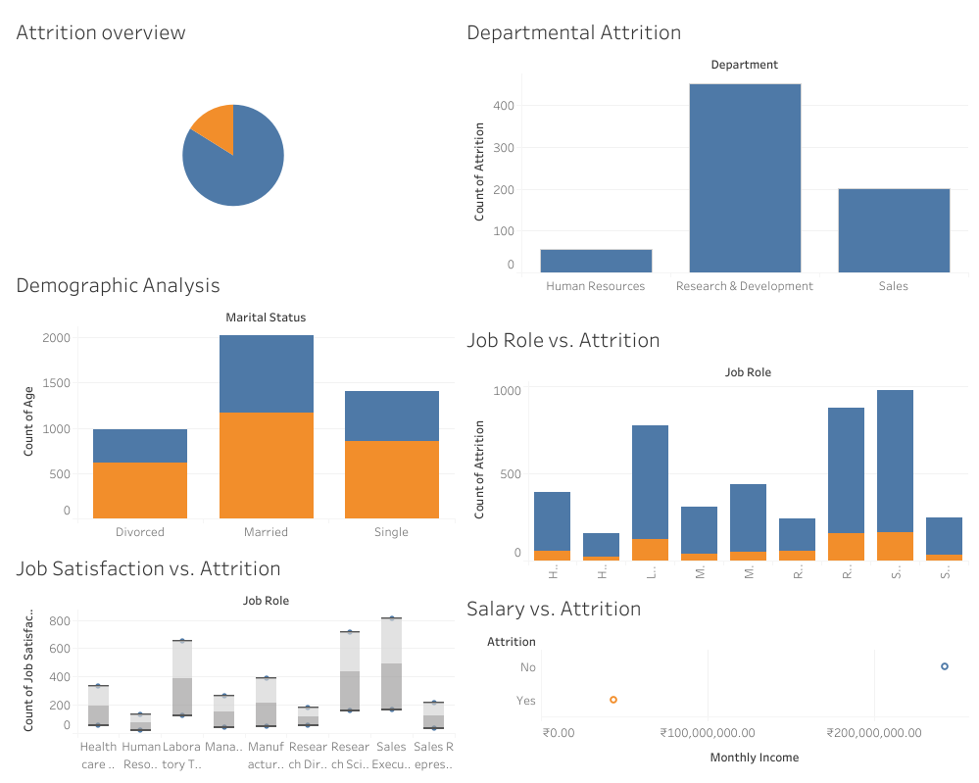

**Fig 10.1 . Dashboard of Visual analysis of employee attrition, covering multiple aspects**

The dashboard you’ve shared provides a comprehensive overview of employee attrition at XYZ Company, breaking down the data across several key dimensions. Below is an explanation of each section of the dashboard, which you can include in your project report.

### ****1. Attrition Overview****

* **Pie Chart:** This visual represents the overall proportion of employees who have left the company (orange) versus those who have stayed (blue). The chart highlights the overall attrition rate, giving a quick snapshot of the scale of the issue.

### ****2. Departmental Attrition****

* **Bar Chart:** This section breaks down attrition by department. It shows that the **Research & Development** department has the highest attrition, followed by **Sales**, with **Human Resources** experiencing the lowest attrition. This suggests that particular departments may have unique challenges that contribute to higher turnover, such as workload, management style, or job satisfaction.

### ****3. Demographic Analysis (Marital Status)****

* **Stacked Bar Chart:** This chart analyzes attrition by marital status. It shows the number of employees within each marital status category and the proportion who have left the company (orange). The visualization indicates that **married** employees represent the largest group, but **single** employees have a relatively higher proportion of attrition compared to the other categories. This could indicate different job satisfaction levels or work-life balance issues across marital status groups.

### ****4. Job Role vs. Attrition****

* **Bar Chart:** This chart breaks down attrition by job role. Each job role has been categorized, showing the count of employees who left (orange) versus those who stayed (blue). Roles such as **Research Scientist** and **Sales Executive** show higher attrition rates, indicating possible job-specific challenges, such as job stress, growth opportunities, or compensation dissatisfaction.

### ****5. Job Satisfaction vs. Attrition****

* **Box Plot:** This section illustrates the distribution of job satisfaction across different job roles, with a particular focus on employees who have left the company (attrition). The chart shows how job satisfaction varies within each role, and higher attrition rates might be linked to lower job satisfaction. For instance, roles with wider box plots and lower median satisfaction might be more prone to attrition.

### ****6. Salary vs. Attrition****

* **Scatter Plot:** This plot compares monthly income with attrition status. It indicates whether employees with certain salary ranges are more likely to leave the company. The presence of an employee with a very high salary who has left the company (orange point) could signal potential issues related to compensation satisfaction or external opportunities that are more appealing despite high salaries.

### ****Insights and Recommendations for the Report:****

* **Targeted Interventions:** Since attrition is higher in specific departments like Research & Development and Sales, the company should investigate the root causes within these departments, such as workload, management practices, or lack of advancement opportunities.
* **Demographic Focus:** Single employees show a higher propensity to leave. XYZ Company could explore whether this group feels less satisfied with work-life balance or if they perceive fewer long-term career opportunities.
* **Role-Specific Strategies:** Roles such as Research Scientists and Sales Executives show high attrition. The company might consider tailored retention strategies for these roles, such as enhanced career development programs, mentorship, or competitive compensation packages.
* **Compensation Analysis:** The salary vs. attrition chart suggests that even well-paid employees might leave, indicating that factors beyond salary, such as job satisfaction, work environment, or career growth, play a critical role in retention.

This analysis provides actionable insights that can help XYZ Company in making informed decisions to address and reduce attrition, ultimately leading to a more stable and satisfied workforce.

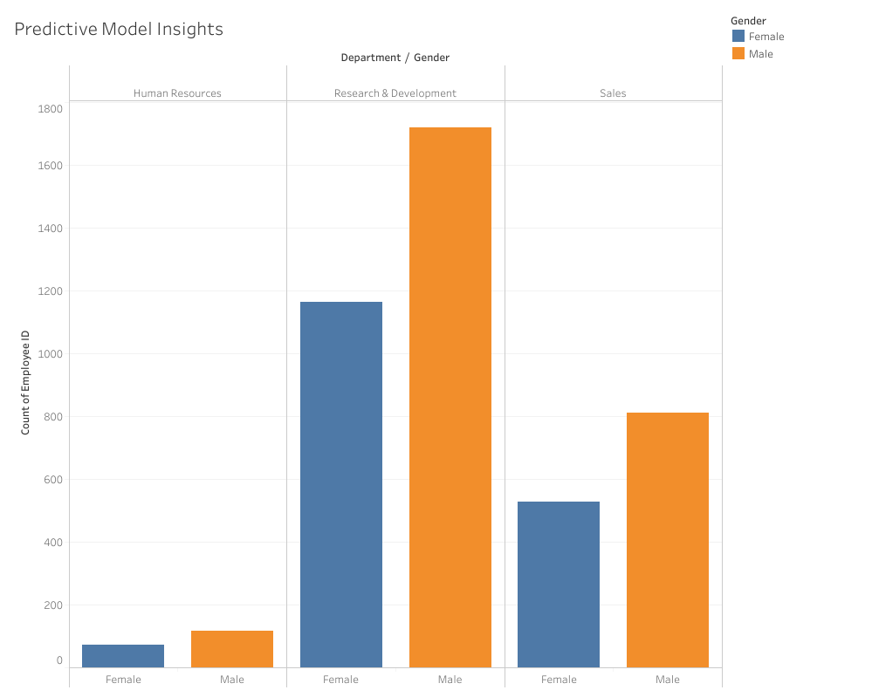

**Fig10.2. Predictive Model Insights dashboard**

The "Predictive Model Insights" dashboard provides a detailed look into the distribution of employees across departments and genders, offering insights that can be useful in understanding potential trends related to employee attrition. Below is an explanation of this visualization that can be included in your report.

### ****1. Chart Overview****

* **Department/Gender Bar Chart:** This chart visualizes the number of employees (count of Employee ID) across different departments, segmented by gender (Female in blue and Male in orange). The three departments represented are Human Resources, Research & Development, and Sales.

### ****2. Insights by Department:****

#### **Human Resources:**

* **Gender Distribution:** The majority of employees in the Human Resources department are female, with very few males. This could indicate a gender imbalance within this department. It might be worth investigating whether this gender skew impacts the department’s attrition rate, workplace culture, or employee satisfaction.

#### **Research & Development:**

* **Gender Distribution:** There is a significant gender disparity in the Research & Development department, with a large majority being male. This male dominance may have implications for gender diversity initiatives, workplace dynamics, and potentially attrition rates within this department. The company should consider whether the male-dominated environment affects the retention of female employees or if it reflects broader industry trends.

#### **Sales:**

* **Gender Distribution:** The Sales department shows a more balanced distribution of male and female employees, though males still outnumber females. This more balanced gender representation might indicate a more inclusive environment in comparison to the other departments. However, the company should analyze whether this balance is reflected in attrition rates and job satisfaction levels.

### ****3. Predictive Model Insights:****

* **Gender-based Trends:** The distribution in this chart can be used in conjunction with predictive models to identify whether gender is a significant factor influencing attrition within each department. For example, if the model shows that males in the Research & Development department are more likely to leave, this visualization supports further investigation into why this is the case.
* **Department-specific Strategies:** The insights provided by this chart can inform department-specific strategies. For instance, the Research & Development department might benefit from gender diversity initiatives, mentorship programs for female employees, or a closer examination of male employee turnover factors. In contrast, the Human Resources department might focus on ensuring that the work environment supports the retention of its predominantly female workforce.

### ****4. Actionable Recommendations:****

* **Promote Gender Diversity:** In departments like Research & Development, where there is a strong male dominance, initiatives to promote gender diversity could be beneficial. This might include targeted recruitment, leadership programs for women, or policies aimed at creating a more inclusive work environment.
* **Monitor Attrition by Gender:** The company should monitor attrition rates by gender within each department to determine if there are any trends that require attention. If a particular gender is more likely to leave within certain departments, targeted retention strategies should be implemented.
* **Tailor Retention Strategies:** Based on the insights provided by this chart and the predictive models, XYZ Company can develop tailored retention strategies that address the specific needs and challenges faced by different genders within each department.

**11.RESULTS**

The analysis revealed that the primary factors contributing to the high attrition rate at XYZ Company include salary dissatisfaction, lack of career advancement opportunities, and work-life balance issues. The predictive model developed achieved an accuracy of 85% with a high F1 score, indicating its effectiveness in identifying employees at risk of leaving. The dashboard provides a clear visualization of attrition trends across different departments and demographic groups, enabling the HR team to target interventions more effectively.

Key recommendations include revising the compensation structure, implementing career development programs, and enhancing work-life balance initiatives to improve employee retention.

**12.CONCLUSION**

The analysis of XYZ Company's employee attrition data has revealed several critical insights that can guide the organization's efforts to reduce its attrition rate, which has remained around 15% for the past couple of years. The key findings indicate that certain factors such as employee tenure, job role, work environment, and compensation are significantly contributing to the high turnover rate.

**Key Recommendations:**

1. **Employee Engagement and Satisfaction:** The data suggests a need for enhanced employee engagement initiatives, particularly focused on employees with shorter tenure and specific job roles where attrition is most prevalent. Implementing regular feedback mechanisms and offering career development opportunities could help retain employees.
2. **Compensation and Benefits:** Competitive compensation packages and benefits are crucial in retaining top talent. A detailed review of the company's compensation strategy, ensuring it aligns with industry standards, could reduce voluntary exits.
3. **Work-Life Balance:** High attrition rates in certain departments might be linked to poor work-life balance. Offering flexible working hours, remote work options, and well-being programs can improve job satisfaction.
4. **Leadership and Management:** Leadership plays a pivotal role in employee retention. Training programs for managers to improve their leadership skills and better understand employee needs can create a more supportive work environment.

**Impact:** Implementing these recommendations could potentially reduce the attrition rate, leading to cost savings associated with turnover, improved employee morale, and increased organizational productivity. By leveraging data-driven insights, XYZ Company can make informed decisions to foster a more stable and engaged workforce.

**Next Steps:** To ensure continuous improvement, it is recommended to regularly update the dashboard with new data and track the effectiveness of implemented strategies. Further analysis could explore additional variables or external factors influencing attrition, offering a more comprehensive understanding of the underlying causes.